Mockup screen for 3rd party / Own Service Provider Tab
1) Grid will show all assigned third party or own party to the claim.
2) After clicking of Add new Party,
3) User first will select Claim type ( Own Damage , PD or BI)
4) Then system will ask for service provider type ( own / TP)
2) Then system will ask Party type ( Insurer, Surveyor, Lawyer, Workshop/Depot ).
4) Add party screen will come accordingly to the selection.

Remarks

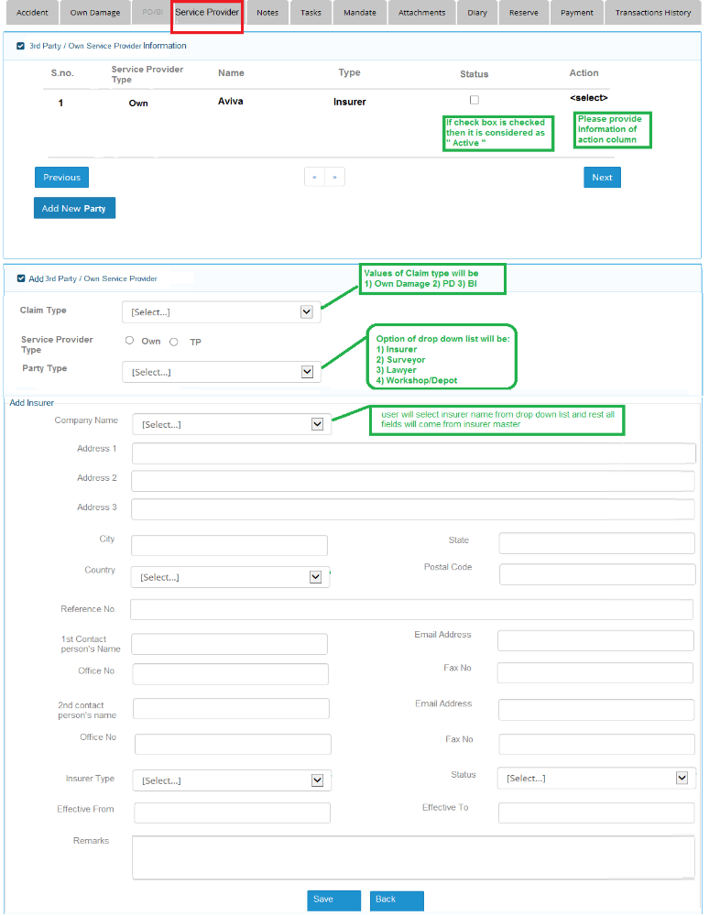
Dexter [24-Sep]: The Own and Third Party Service Providers that are created are to be attached to the relevant Third Party Claimant input during the OD / PD / BI Creation. E.g. If Jason is a Third Party Claimant created in a BI Claim and CDGI creates 1 TP Lawyer, 1 TP Workshop, it means that Jason is the one who has engaged these two Service Providers and CDGI are to keep track of their existences during Claim Processes / Reserves / Payments.

